**Experiment: 11**

PART A

(PART A: TO BE REFFERED BY STUDENTS)

**Aim:** **To study inheritance in C++.**

**Learning Outcomes: Learner would be able to**

Implement inheritance.

Task 1: Assume that a bank maintains two kinds of accounts for customers, one called as savings and the other as current account. The savings account provides compound interest and withdrawal facilities but no cheque book facility. The current account provides cheque book facility but no interest. Current account holders should also maintain a minimum balance and if the balance falls below this level a service charge is imposed. Create a class account that stores customer name, account number and type of account. From this derive the classes cur_acct and sav_acct to make them more specific to their requirements. Include necessary member functions in order to achieve the following tasks:

(a) Accept the deposit from a customer and update the balance.

(b) Display the balance.

(c) Compute and deposit interest.

(d) Permit withdrawal and update the balance.

(e) Check for the minimum balance, impose penalty, necessary and update the balance.

Task 2: An educational institution wishes to maintain a database of its employees. The database is divided into a number of classes whose hierarchical relationships are shown in following figure. The figure also shows the minimum information required for each class. Specify all classes and define functions to create the database and retrieve individual information as and when required.

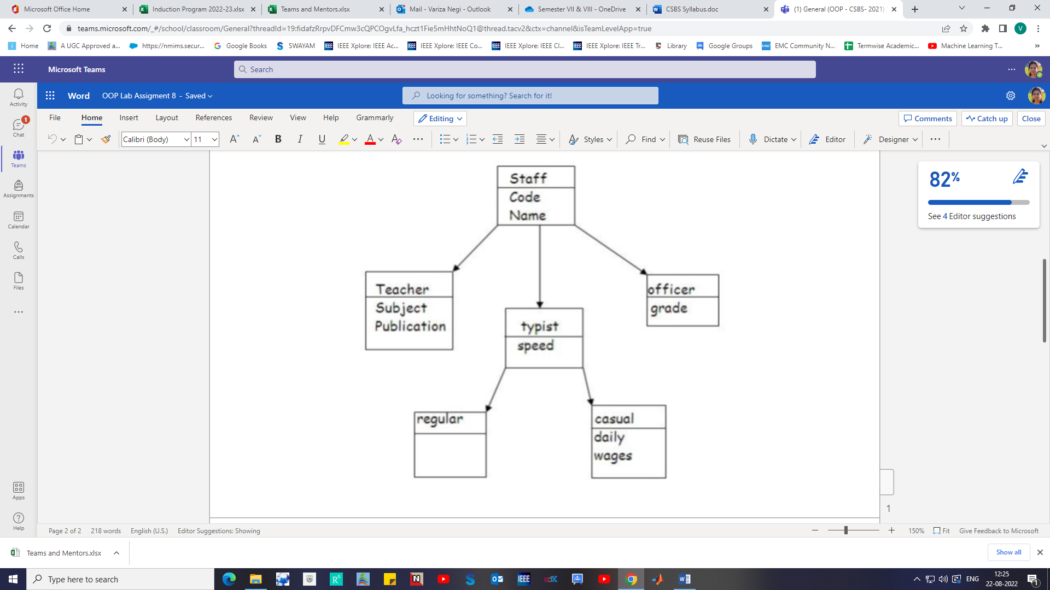

PART B

(PART B: TO BE COMPLETED BY STUDENTS)

Students must submit the soft copy as per following segments within two hours of the practical. The soft copy must be uploaded on the portal at the end of the practical. The filename should be **PPS_batch_rollno_experimentno Example: PPS_B2_B001_Exp1**

|  |  |
| --- | --- |
| **Roll No.:** | **Name:** |
| **Prog/Yr/Sem:** | **Batch:** |
| **Date of Experiment:** | **Date of Submission:** |

**Task 1:**

**Task 2:**

**Conclusion (Learning Outcomes):** Reflect on the questions answered by you jot down your learnings about the Topic: Structure and Union